Nalongsone Danddank

Rich Fritz

Ryan Kinsella

Gilbert Ponsness

Marc Wedo

ICS372-02

21-MAR-2021

Grocery Store Design Document

**USE CASES:**

**Remove a Member**

|  |  |
| --- | --- |
| Action Performed by the Actor | Response from the system |
| 1. The Employee initiates remove a Member |  |
|  | 1. The System asks for the Members ID |
| 1. The Employee enters the Member ID |  |
|  | 1. The System checks the member list to see if it is a valid Member. If valid the member is removed, if not return an error |

**Add a product**

|  |  |
| --- | --- |
| Action Performed by the Actor | Responses from the system |
| 1. Employee initiates adding a new product |  |
|  | 1. The System asks for the product name, id, stock on hand and current price, |
| 1. Employee enters the product name, id, stock on hand, current price, and reorder level |  |
|  | 1. The system checks the product name.   If product does not exist new product is added with product name, product id, stock on hand, current price, and reorder level. An Order is generated with qty = 2 * reorder level  If product exists, the system does not add product and returns an error that product <name> already exists |

**Check out Items**

|  |  |
| --- | --- |
| Action Performed by the Actor | Responses from the system |
| 1. The member comes to the check-out counter with a cart of grocery items. |  |
| 1. The cashier issues a request to check out items. |  |
|  | 1. The system asks for a product id and quantity for one item. |
| 1. The cashier inputs the product id and quantity for an item into the system. |  |
|  | 1. The system fetches the price for that individual item and computes the total price. |
|  | 1. The system outputs the product name, quantity, unit price, and total price for display. |
|  | 1. The system asks for product id and quantity of the next item. |
| 1. The cashier inputs the product id and quantity for that item into the system, or enters zero. |  |
|  | 1. If the cashier entered zero, proceed to Step 10. Otherwise, return to Step 5. |
|  | 1. The system calulates the grand total. |
|  | 1. The system outputs the grand total for display. |
| 1. The cashier asks the member for cash. If the member pays fully, the cashier may finalize transaction. |  |
|  | 1. The system reduces amount on hand for all products according to quantity purchased. |
|  | 1. If there is a product whose amount on hand is equal to or below the reorder level, the system must reorder twice the reorder level. |
|  | 1. The system must display a message saying that the item will be reordered, how much was reordered, and what the order number is. |
|  | 1. Return to Step 14 if there is another product that meets the criteria. |
| 1. The cashier closes the main terminal, or issues another check-out request. |  |

**Use case: Process Shipment – Prepared by Marc Wedo**

|  |  |
| --- | --- |
| Actions Performed by the Actor | Responses From the System |
| 1. A delivery of products arrives from a supplier. |  |
| 1. The clerk issues a request to Process Shipment. |  |
|  | 1. The system asks for the order number. |
| 1. The clerk enters the order number into the system. |  |
|  | 1. The system retrieves the order information. |
|  | 1. The system locates the product in the order and uses the current quantity in stock and the quantity listed on the order to calculate the new total quantity. |
|  | 1. The system updates the status of the order from outstanding to complete. |
|  | 1. The system displays the product ID, product name, and new total quantity. |
|  | 1. The system asks if the clerk wants to process another order. |
| 1. The clerk answers in the affirmative or in the negative. |  |
|  | 1. If the answer is in the affirmative, system goes to step 3. Otherwise, it exits. |

**Retrieve Member Info**

|  |  |
| --- | --- |
| Action Performed by the Actor | Responses from the System |
| 1. Employee initiates retrieve member info |  |
|  | 2. System requests string input |
| 3. Employee enters string |  |
|  | 4. System checks for matching string |
|  | 5. System displays address, ID, and fee paid for all members whose name begins with the input string |

**Print Transactions Use Case**

|  |  |
| --- | --- |
| Action Performed by the Actor | Responses from the system |
| 1. The clerk issues a request to get member transactions. |  |
|  | 1. The system asks for the user ID of the member and the date for which the transactions are needed. |
| 1. The clerk enters the identity of the user and the date. |  |
|  | 1. If the ID is valid, the system outputs information about all transactions completed by the user on the given date. For each transaction, it shows the type of transaction (kind of products) and the title of the products. |
| 1. Clerk prints out the transactions and hands them to the user. |  |

**Sequence Diagrams:**

**Remove a member – prepared by Richard Fritz**

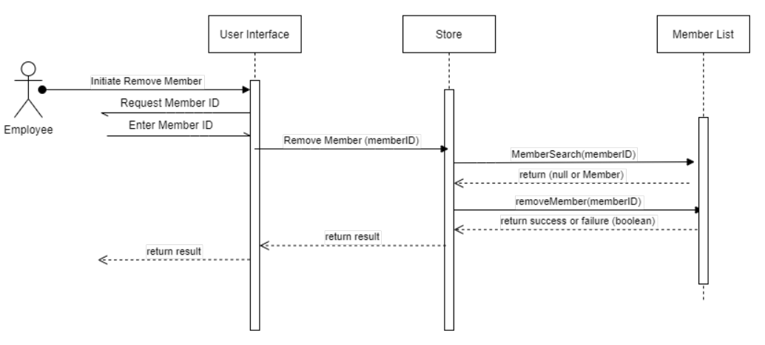

**Add a product – prepared by Richard Fritz**

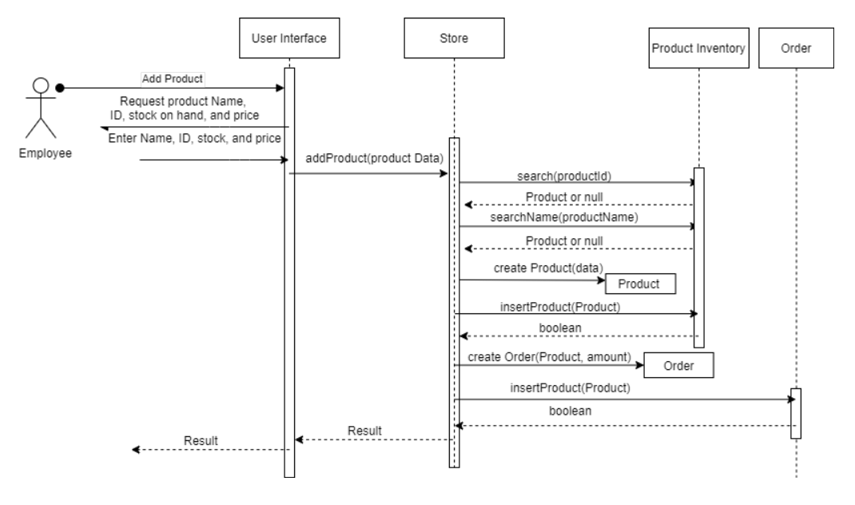

**Check out a member’ items**

**Process shipment – Prepared by Marc Wedo**

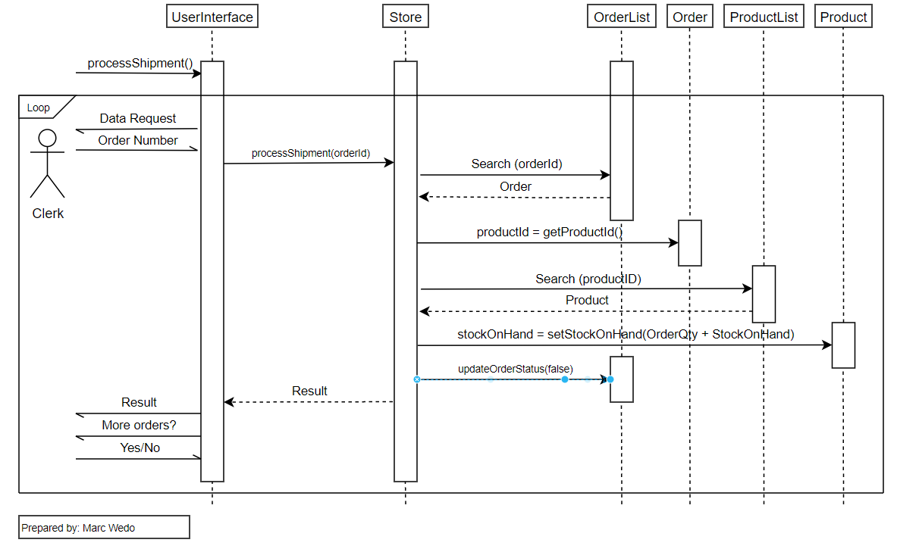

**Retrieve member info**

**Print transactions**

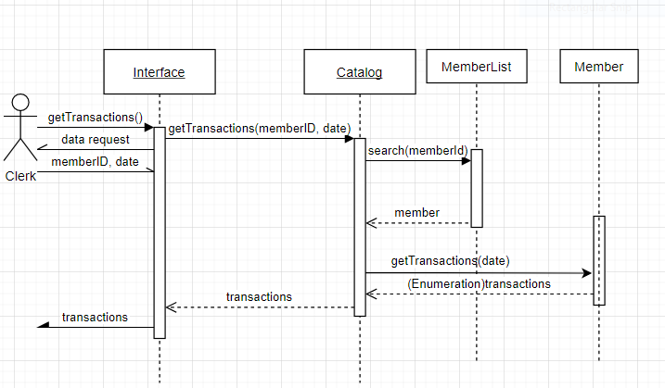

**Class Diagrams:**

**UserInterface – Prepared by Richard Fritz**

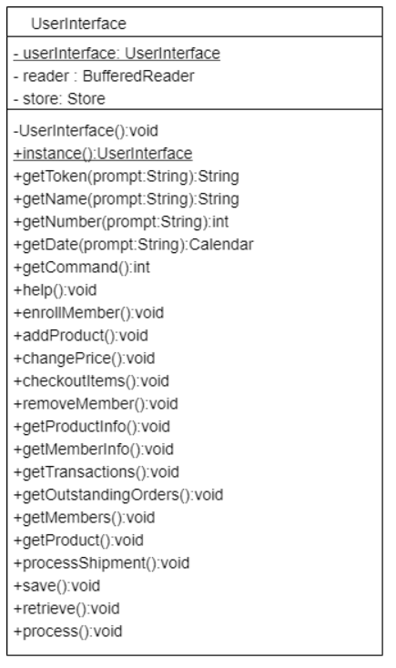

**Member – Prepared by Richard Fritz**

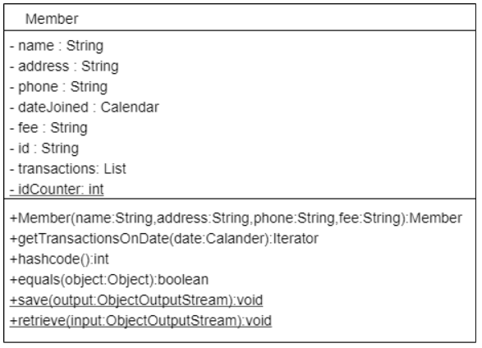

**MemberList – Prepared by Richard Fritz**

